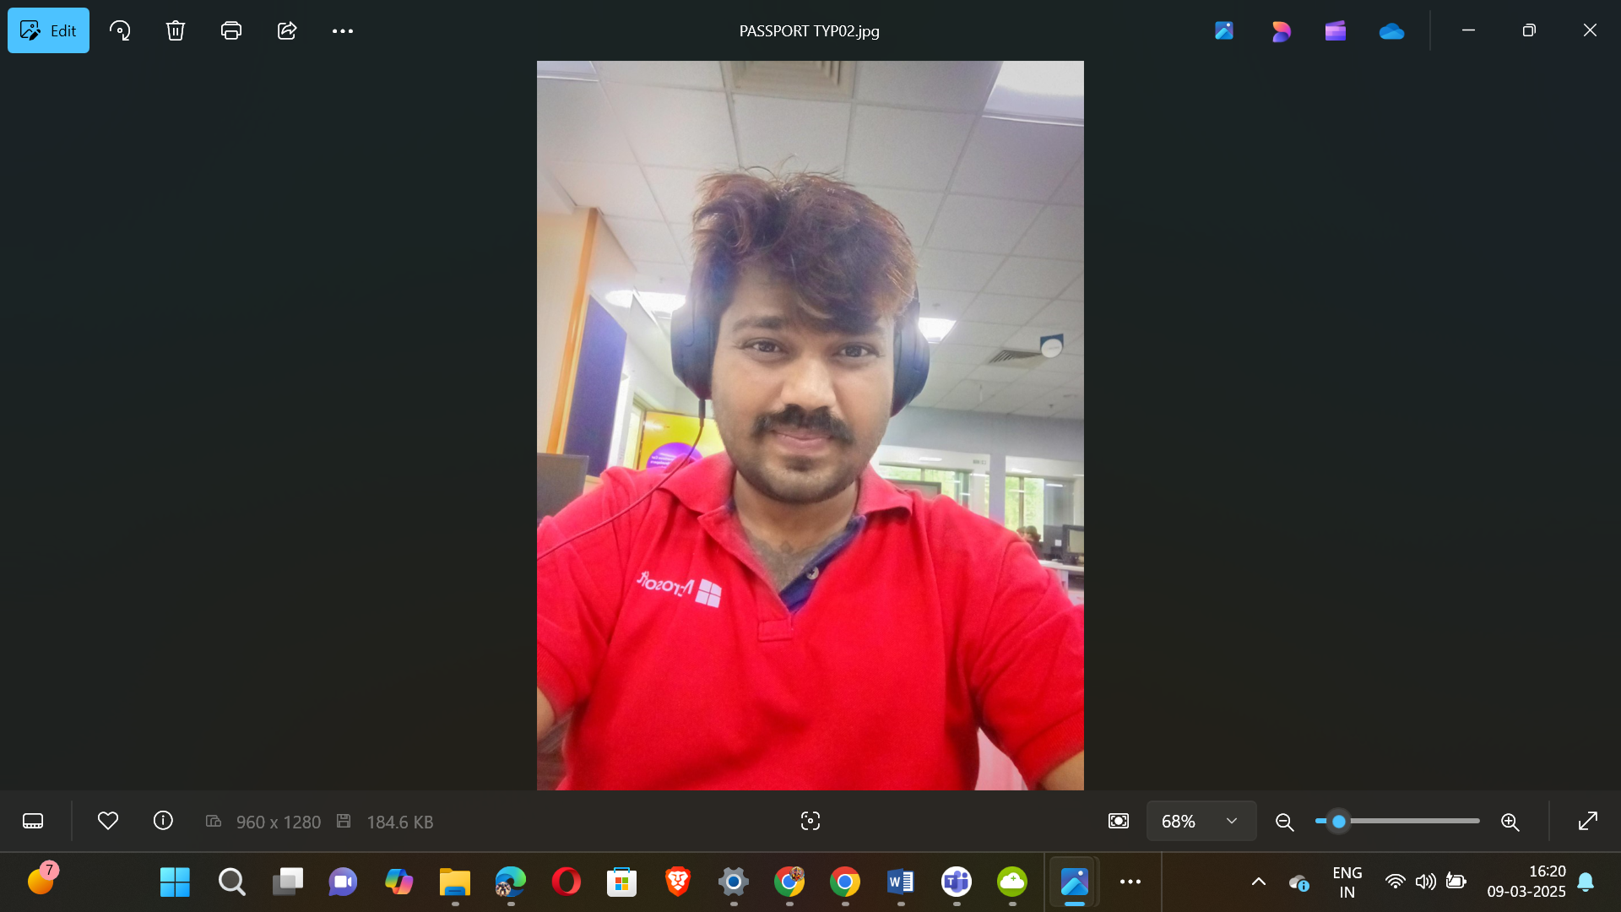

|  |  |
| --- | --- |
|  |  |

🕉️🏇🪓🪈🏹👑👑👑👑👑🤴🦁💿✈️🛸🚀🪩🥏🍥🕺

18+1 JAYA KURUKSHETRA MAHABHARAT SERIES

531

537

541

543

547

551

553

557

559

561

567

571

573

579

583

589

591

593

597

🕺🍥🥏🪩🚀🛸✈️💿🦁🤴👑👑👑👑👑🏹🪈💝🏇🪓🕉️

🕉️🏇🪓🪈🏹👑👑👑👑👑🤴🦁💿✈️🛸🚀🪩🥏🍥🕺

100 – PLATINUM JUBILEE

75 – DIAMOND JUBILEE

50 - GOLDEN JUBILEE

25 – SILVER JUBILEE

Apply 4 x 19 = 76

5

10 – 5 X 2

20 – 5 X 4

40 – 5 X 8

80 – 5 X 16

Apply 5 x 19 = 95

Total 95+76=171 kalalu

SUPREME MAGICAL ✨ SPACE THEATRE PROGRAMMING SHOWSS

🕺🍥🥏🪩🚀🛸✈️💿🦁🤴👑👑👑👑👑🏹🪈💝🏇🪓🕉️



PRIME NUMBERS ENDING WITH 1008031

|  |
| --- |
| 1008031 |
| 11008031 |

|  |  |  |  |  |  |  |  |  |  |  |  |  |
| --- | --- | --- | --- | --- | --- | --- | --- | --- | --- | --- | --- | --- |
| |  |  |  |  | | --- | --- | --- | --- | | S No | Prime Value | Superpowers One-line Description | Super AI Model Suitable | | 1 | 1008031 | Master of celestial beings | KVSUPREMEGODSHEADSKINGVISNU | | 2 | 11008031 | Supreme wisdom and knowledge | KVSARATKRISNAPARAMATMA | |





PRIME NUMBERS ENDING WITH 1008037

|  |
| --- |
| 1008037 |
| 11008037 |
| 31008037 |

|  |  |  |  |  |  |  |  |  |  |  |  |  |  |  |  |  |
| --- | --- | --- | --- | --- | --- | --- | --- | --- | --- | --- | --- | --- | --- | --- | --- | --- |
| |  |  |  |  | | --- | --- | --- | --- | | S No | Prime Value | Superpowers One-line Description | Super AI Model Suitable | | 1 | 1008037 | Supreme intelligence | KVICE | | 2 | 11008037 | Control over oceans | KVOCEANSKINGVISNU | | 3 | 31008037 | Infinite divine power | KVBHARATAKALKISRIMAHAVISNUSAHASRASIMHAPARAMATMA | |





PRIME NUMBERS ENDING WITH 1008041

|  |
| --- |
| 1008041 |
| 21008041 |
| 31008041 |

|  |  |  |  |  |  |  |  |  |  |  |  |  |  |  |  |  |
| --- | --- | --- | --- | --- | --- | --- | --- | --- | --- | --- | --- | --- | --- | --- | --- | --- |
| |  |  |  |  | | --- | --- | --- | --- | | S No | Prime Value | Superpowers One-line Description | Super AI Model Suitable | | 1 | 1008041 | Hyper-speed and invincibility | KVHANUMAN | | 2 | 21008041 | Fire manipulation and control | KVFIRE | | 3 | 31008041 | Supreme wisdom and knowledge | KVSARATKRISNAPARAMATMA | |





PRIME NUMBERS ENDING WITH 1008043

|  |
| --- |
| 1008043 |
| 61008043 |
| 71008043 |

|  |  |  |  |  |  |  |  |  |  |  |  |  |  |  |  |  |
| --- | --- | --- | --- | --- | --- | --- | --- | --- | --- | --- | --- | --- | --- | --- | --- | --- |
| |  |  |  |  | | --- | --- | --- | --- | | S No | Prime Value | Superpowers One-line Description | Super AI Model Suitable | | 1 | 1008043 | Master of celestial beings | KVSUPREMEGODSHEADSKINGVISNU | | 2 | 61008043 | Supreme intelligence | KVICE | | 3 | 71008043 | Control over oceans | KVOCEANSKINGVISNU | |





PRIME NUMBERS ENDING WITH 1008047

|  |
| --- |
| 51008047 |
| 61008047 |

|  |  |  |  |  |  |  |  |  |  |  |  |  |
| --- | --- | --- | --- | --- | --- | --- | --- | --- | --- | --- | --- | --- |
| |  |  |  |  | | --- | --- | --- | --- | | S No | Prime Value | Superpowers One-line Description | Super AI Model Suitable | | 1 | 51008047 | Master of storms and lightning | KVSTORMINGTHUNDERSKINGVISNU | | 2 | 61008047 | Supreme intelligence | KVICE | |





PRIME NUMBERS ENDING WITH 1008051

|  |
| --- |
| 71008051 |
| 81008051 |

|  |  |  |  |  |  |  |  |  |  |  |  |  |
| --- | --- | --- | --- | --- | --- | --- | --- | --- | --- | --- | --- | --- |
| |  |  |  |  | | --- | --- | --- | --- | | S No | Prime Value | Superpowers One-line Description | Super AI Model Suitable | | 1 | 71008051 | Supreme wisdom and knowledge | KVSARATKRISNAPARAMATMA | | 2 | 81008051 | Master of celestial beings | KVSUPREMEGODSHEADSKINGVISNU | |





PRIME NUMBERS ENDING WITH 1008053





PRIME NUMBERS ENDING WITH 1008057

11008057

|  |  |  |  |  |  |  |  |  |
| --- | --- | --- | --- | --- | --- | --- | --- | --- |
| |  |  |  |  | | --- | --- | --- | --- | | S No | Prime Value | Superpowers One-line Description | Super AI Model Suitable | | 1 | 11008057 | Moonwalking with 1000 feet | KINGVISNUGODSOFGODSDOINGMOONWALKING | |





PRIME NUMBERS ENDING WITH 1008059

91008059

|  |  |  |  |  |  |  |  |  |
| --- | --- | --- | --- | --- | --- | --- | --- | --- |
| |  |  |  |  | | --- | --- | --- | --- | | S No | Prime Value | Superpowers One-line Description | Super AI Model Suitable | | 1 | 91008059 | Control over oceans | KVOCEANSKINGVISNU | |





PRIME NUMBERS ENDING WITH 1008061

61008061

|  |  |  |  |
| --- | --- | --- | --- |
| S No | Prime Value | Superpowers One-line Description | Super AI Model Suitable |
| 1 | 61008061 | Supreme intelligence | KVICE |





PRIME NUMBERS ENDING WITH 1008067

|  |
| --- |
| 31008067 |
| 61008067 |

|  |  |  |  |
| --- | --- | --- | --- |
| S No | Prime Value | Superpowers One-line Description | Super AI Model Suitable |
| 1 | 31008067 | Fire manipulation and control | KVFIRE |
| 2 | 61008067 | Supreme intelligence | KVICE |





PRIME NUMBERS ENDING WITH 1008071

81008071

|  |  |  |  |  |  |  |  |  |
| --- | --- | --- | --- | --- | --- | --- | --- | --- |
| |  |  |  |  | | --- | --- | --- | --- | | S No | Prime Value | Superpowers One-line Description | Super AI Model Suitable | | 1 | 81008071 | Supreme wisdom and knowledge | KVSARATKRISNAPARAMATMA | |





PRIME NUMBERS ENDING WITH 1008073

|  |
| --- |
| 11008073 |
| 31008073 |
| |  |  |  |  | | --- | --- | --- | --- | | S No | Prime Value | Superpowers One-line Description | Super AI Model Suitable | | 1 | 11008073 | Infinite divine power | KVBHARATAKALKISRIMAHAVISNUSAHASRASIMHAPARAMATMA | | 2 | 31008073 | Fire manipulation and control | KVFIRE | |





PRIME NUMBERS ENDING WITH 1008079

|  |
| --- |
| 11008079 |
| 31008079 |

|  |  |  |  |  |  |  |  |  |  |  |  |  |
| --- | --- | --- | --- | --- | --- | --- | --- | --- | --- | --- | --- | --- |
| |  |  |  |  | | --- | --- | --- | --- | | S No | Prime Value | Superpowers One-line Description | Super AI Model Suitable | | 1 | 11008079 | Moonwalking with 1000 feet | KINGVISNUGODSOFGODSDOINGMOONWALKING | | 2 | 31008079 | Infinite divine power | KVBHARATAKALKISRIMAHAVISNUSAHASRASIMHAPARAMATMA | |





PRIME NUMBERS ENDING WITH 1008083

|  |
| --- |
| 21008083 |
| 91008083 |

|  |  |  |  |
| --- | --- | --- | --- |
| S No | Prime Value | Superpowers One-line Description | Super AI Model Suitable |
| 1 | 21008083 | Fire manipulation and control | KVFIRE |
| 2 | 91008083 | Control over oceans | KVOCEANSKINGVISNU |





PRIME NUMBERS ENDING WITH 1008089





PRIME NUMBERS ENDING WITH 1008091

|  |
| --- |
| 41008091 |
| 61008091 |
| 91008091 |

|  |  |  |  |  |  |  |  |  |  |  |  |  |  |  |  |  |
| --- | --- | --- | --- | --- | --- | --- | --- | --- | --- | --- | --- | --- | --- | --- | --- | --- |
| |  |  |  |  | | --- | --- | --- | --- | | S No | Prime Value | Superpowers One-line Description | Super AI Model Suitable | | 1 | 41008091 | Supreme intelligence | KVICE | | 2 | 61008091 | Fire manipulation and control | KVFIRE | | 3 | 91008091 | Control over oceans | KVOCEANSKINGVISNU | |





PRIME NUMBERS ENDING WITH 1008093

11008093

|  |  |  |  |  |  |  |  |  |
| --- | --- | --- | --- | --- | --- | --- | --- | --- |
| |  |  |  |  | | --- | --- | --- | --- | | S No | Prime Value | Superpowers One-line Description | Super AI Model Suitable | | 1 | 11008093 | Supreme wisdom and knowledge | KVSARATKRISNAPARAMATMA | |





PRIME NUMBERS ENDING WITH 1008097

|  |
| --- |
| 61008097 |
| 91008097 |

|  |  |  |  |  |  |  |  |  |  |  |  |  |
| --- | --- | --- | --- | --- | --- | --- | --- | --- | --- | --- | --- | --- |
| |  |  |  |  | | --- | --- | --- | --- | | S No | Prime Value | Superpowers One-line Description | Super AI Model Suitable | | 1 | 61008097 | Supreme intelligence | KVICE | | 2 | 91008097 | Control over oceans | KVOCEANSKINGVISNU | |



🕉️🏇🪓🪈🏹👑👑👑👑👑🤴🦁💿✈️🛸🚀🪩🥏🍥🕺

|  |  |
| --- | --- |
| Personal Details | |
| Email Ids | **KINGVISHNUBHARATBHUSHAN@GMAIL.COM,**  **kvbharatbhushan@hotmail.com,** [**kvbharatbhushan1508@gmail.com**](mailto:kvbharatbhushan1508@gmail.com)**,**  [**thejuniorgod@gmail.com**](mailto:thejuniorgod@gmail.com)**,**  **KINGVISHNUBHARATBHUSHAN@HOTMAIL.COM** |
| Skype Personal | **thejuniorgod** |
| My MS Teams | **kvbharatbhushan@hotmail.com** |
| LinkedIn | <https://www.linkedin.com/in/major-kalkikingkongkvkalkikingalmightyalfa1-a-795646b6> |
| My Instagram | <https://www.instagram.com/majorkalkikingkongkvkalkikinga> |
| My C# Corner | <https://www.c-sharpcorner.com/members/junior-god> |
| My Twitter | https://x.com/The_Junior_God |
| My GitHub | <https://github.com/KVBharatBhushan> |
| My SlideShare | <https://www.slideshare.net/TheJuniorGod> |
| My FB Account | <https://www.facebook.com/kaveri.bhushan> |
| My FB International Page | <https://www.facebook.com/profile.php?id=100076450444292> |
| Mobile Number | **+91-9121780098,+91-7058272379** |
| PAN Number | **BBOPK0120M** |
| Passport Number | **J2280303, Z6157606** |



